**DAILY ONLINE ACTIVITIES SUMMARY**

|  |  |  |  |  |  |  |  |  |
| --- | --- | --- | --- | --- | --- | --- | --- | --- |
| **Date:** | **27/05/2020** | | | | | **Name:** | **Varshitha V Makam** | |
| **Sem & Sec** | **8 B** | | | | | **USN:** | **4AL16CS118** | |
| **Online Test Summary** | | | | | | | | |
| **Subject** | | **Internet Of Things** | | | | | | |
| **Max. Marks** | | **30** | | **Score** | | | **27** | |
| **Certification Course Summary** | | | | | | | | |
| **Course** | Intro to Hadoop | | | | | | | |
| **Certificate Provider** | | | **GreatLearning** | | **Duration** | | | **4 Hours** |
| **Coding Challenges** | | | | | | | | |
| **Problem Statement:** | | | | | | | | |
| **Status: done** | | | | | | | | |
| **Uploaded the report in Github** | | | | | **yes** | | | |
| **If yes Repository name** | | | | | **https://github.com/alvas-education-foundation/Varshitha-Makam** | | | |
| **Uploaded the report in slack** | | | | | **yes** | | | |

Online Test Details:

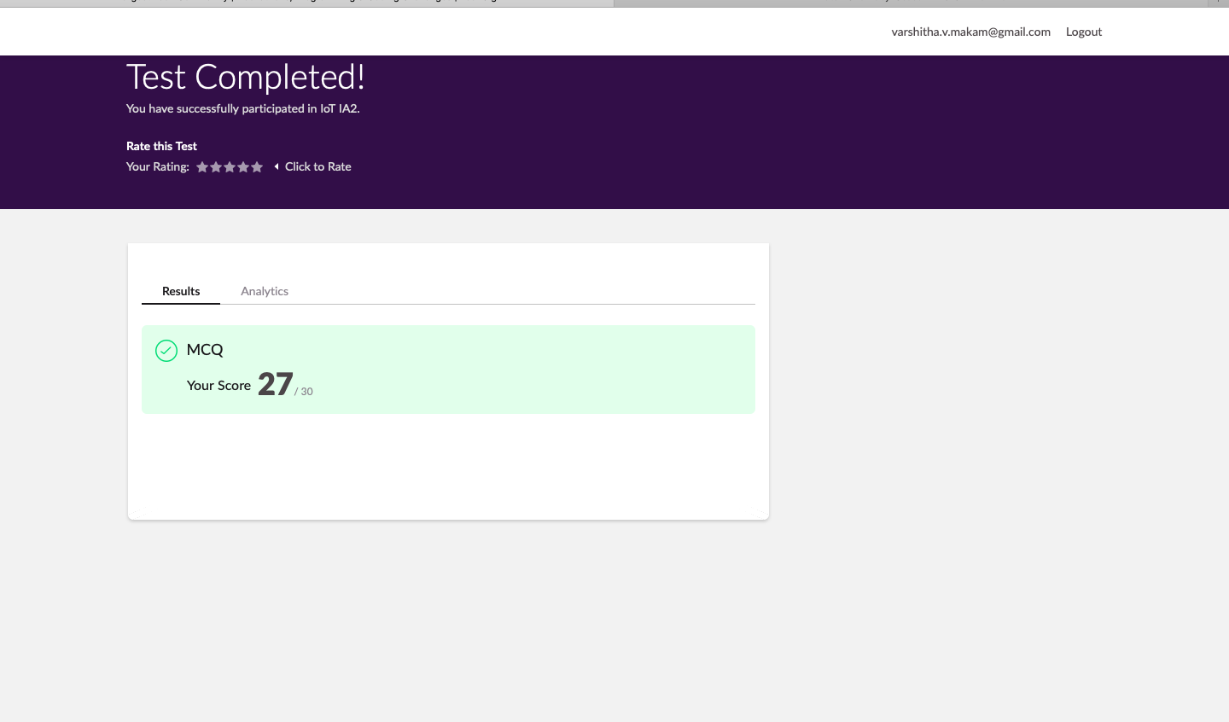

Certification Course Details:



Coding Challenges Details:

Program 🡪Given an array A of size N where the array elements contain values from 1 to N with duplicates, the task is to find total number of subarrays, which start and end with the same element.

